**Practical No. 2**

1. **Write a program to implement MongoDB data models.**
2. **Inserting document in ‘students’ collection**



1. **Display all records from ‘students’ collection**

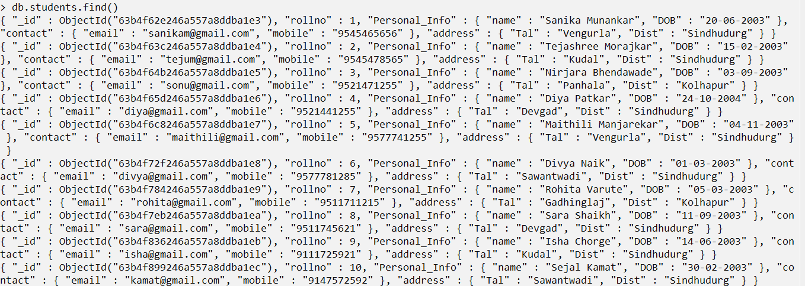

1. **Display all records from ‘student’ collection via ‘pretty()’ command**

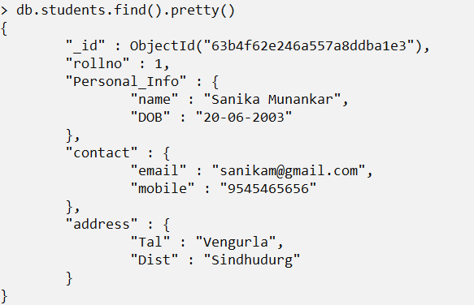

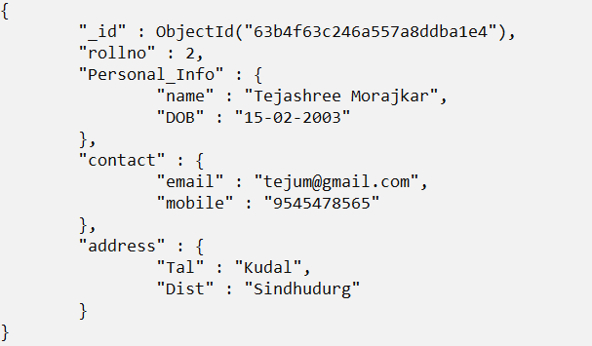

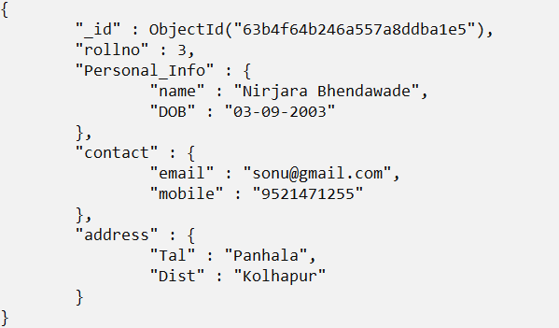

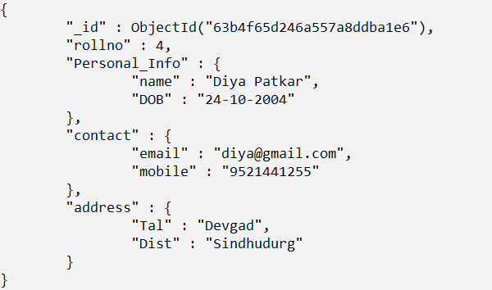

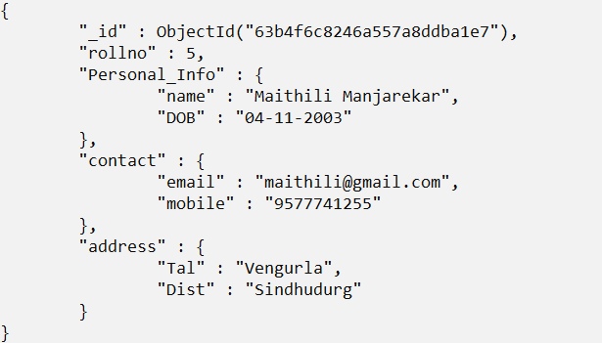

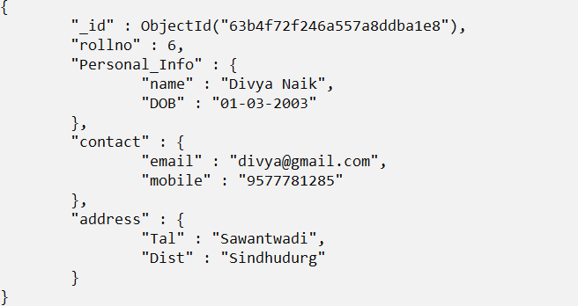

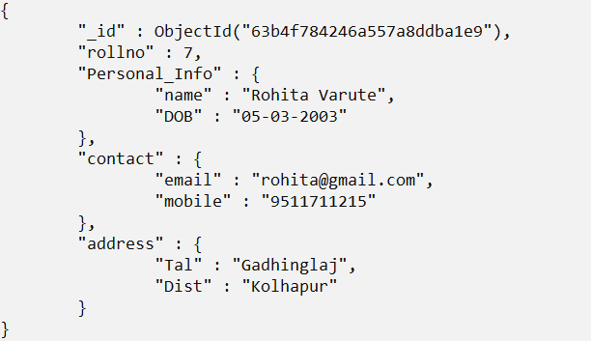

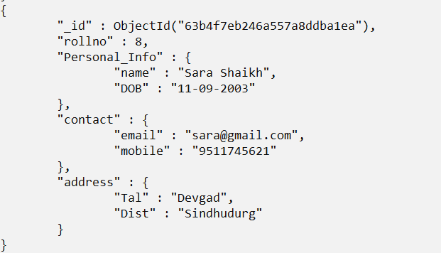

1. **Projection of records in ‘students’ collection**

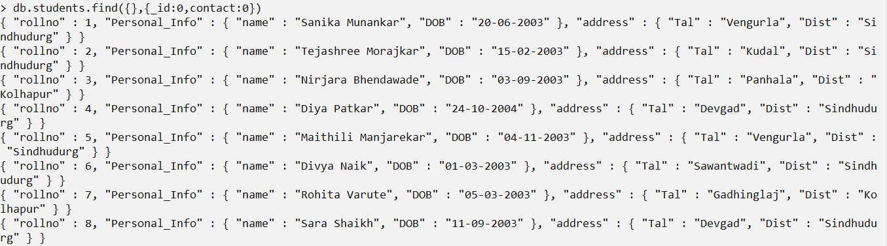

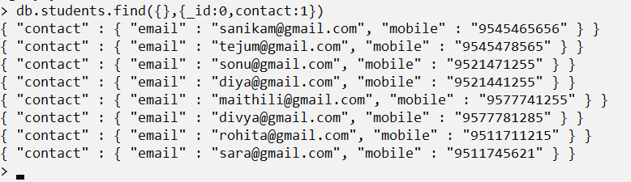

1. **Display Specific record of ‘students’ collection via projection**



1. **Projection of Selective Records in ‘students’ collection**

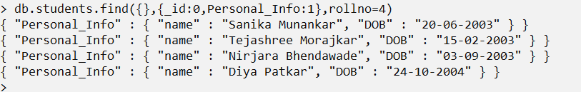

1. **Sorting the projection records of ‘students’ collection via sort**

**method(descending)**

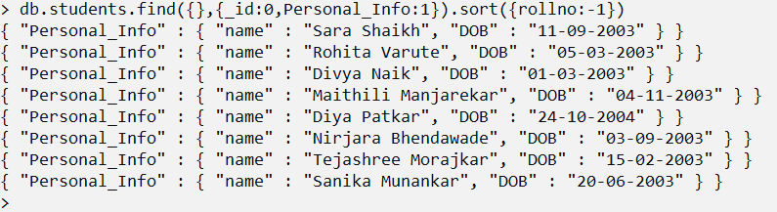

1. **Projection of records within specified range in ‘students’ collection**

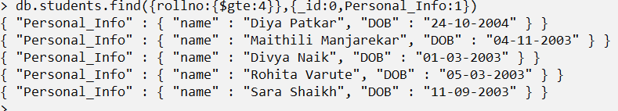

1. **Adding records in ‘employees’ collections**



1. **Display all records of ‘employees’ collection**

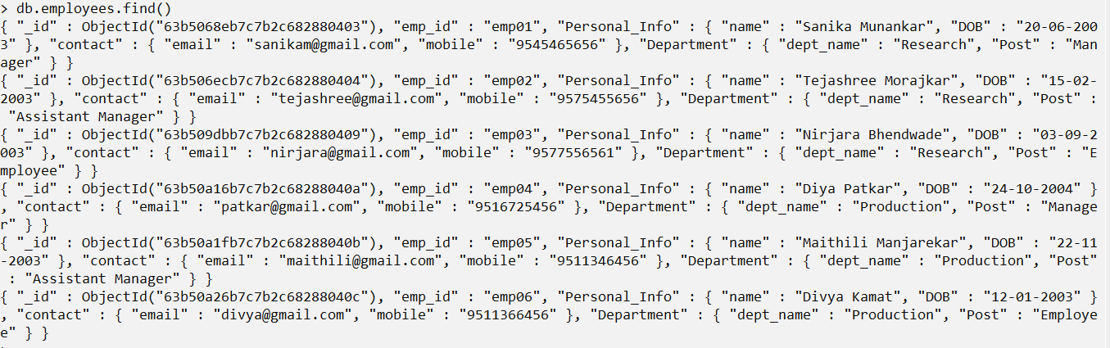

1. **Display all records in ‘employees’ collection via pretty() command**

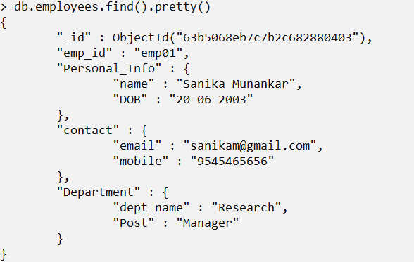

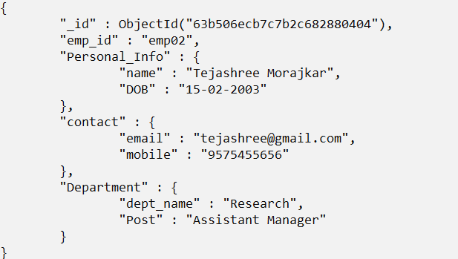

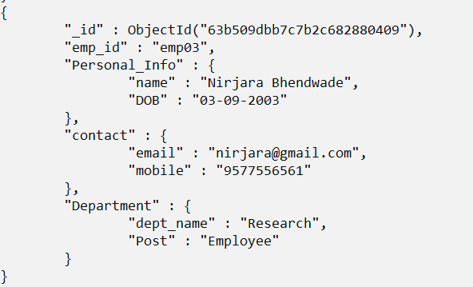

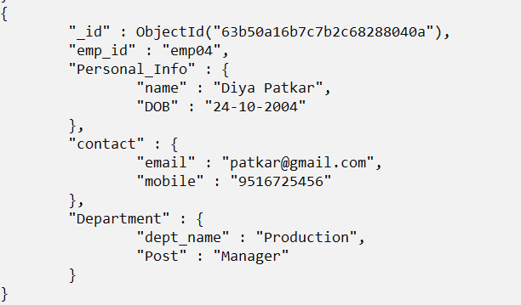

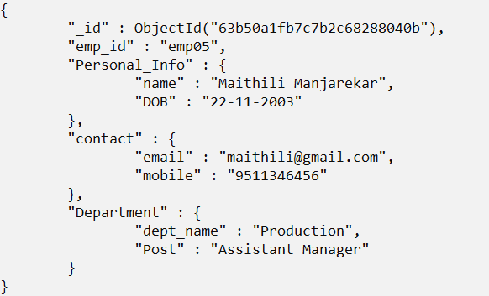

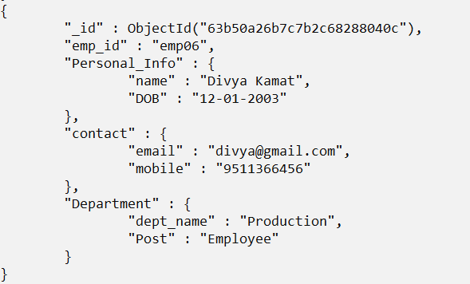

1. **Projection of records in ‘employees’ collection**

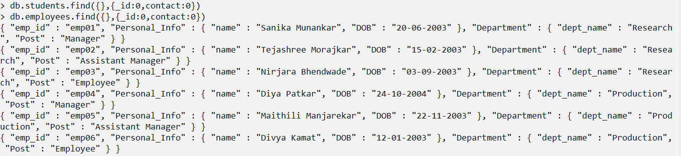

1. **Projection of specific record in ‘employees’ collection**



1. **Projection of selective record in ‘employees’ collection**

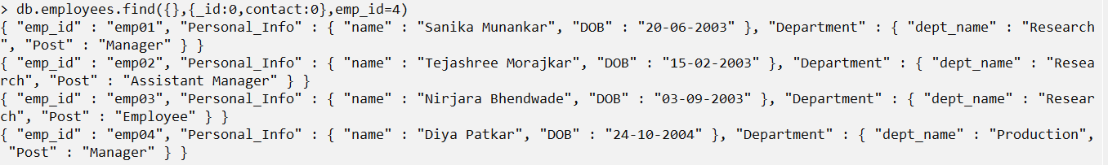

1. **Sorting the projection records of ‘employees’ collection via sort**

**method(descending)**

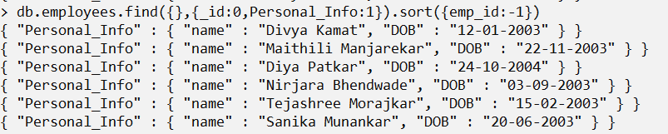

1. **Projection of records within specified range in ‘employees’ collection**

